**FULL STACK PROJECT : LearnHub E-Learning Platform**

**Project Overview**

LearnHub is a dynamic, interactive e-learning web platform built with HTML, CSS, JavaScript, PHP, and MySQL. The platform delivers comprehensive online education features, including secure user registration and login, multiple course offerings, downloadable study materials, online assessments, and automatic certification—all housed in a modern, intuitive user interface.

**Abstract**

This project introduces LearnHub, an advanced web-based platform designed for self-paced digital learning. The system enables users to:

* Create secure accounts and log in.
* Browse a curated catalog of in-demand courses.
* Access detailed course notes and supplementary material.
* Participate in interactive online exams.
* Instantly download digital certificates upon successful course completion.

The platform combines contemporary web technologies to deliver an engaging, accessible, and automated learning experience. By integrating user authentication, real-time interaction, and client-side PDF generation, LearnHub streamlines the complete learning process within a visually appealing interface. This project demonstrates how modern web development tools can transform traditional learning into a scalable, user-friendly digital solution.

**Introduction**

**Context & Motivation**

Online learning is revolutionizing global access to education, offering unparalleled flexibility and accessibility to learners. The proliferation of internet-connected devices has amplified the need for platforms that are not only accessible but also secure, interactive, and versatile.

**Project Objective**

LearnHub’s primary objective is to address these evolving needs by providing:

* **A robust user authentication system** for secure access.
* **Easy navigation and discovery** of quality educational content.
* **Seamless transition from learning to assessment and certification**, motivating learners and validating their achievements instantly.
* **A visually attractive, responsive design** that works across devices.

This platform exemplifies the fusion of solid backend security and responsive frontend design, making high-quality education not only accessible but also rewarding and effective.

**Methodology**

**Technical Stack**

* **Frontend:**
  + **HTML5:** Semantic structure for all pages (login, registration, dashboard, course details, exam, certificate).
  + **CSS3 & Custom Styling:** Custom style sheet for layouts, colors, responsive grids, and form enhancements.
  + **JavaScript (ES6):** Dynamic interactivity such as rendering courses, handling navigation, managing exams, showing/hiding sections, and generating/downloadable PDFs.
* **Backend:**
  + **PHP:** Handles session management, form submissions, user authentication, and server-side validation.
  + **MySQL:**
    - users table for user registration and login.
    - user_course_completion table records completed courses, scores, and related details.
* **Client-side PDF Generation:**
  + **jsPDF Library:** Used to create study notes as downloadable PDFs and auto-generate completion certificates directly on the client side, reducing server load and enhancing user experience.

**Key Features & Styling**

**Core Features**

* **Secure User Authentication:**
  + Registration with hashed passwords.
  + Robust session management—users must log in to access dashboard and course content.
* **Course Catalog:**
  + Responsive "card" grid showcasing images, titles, and summaries for easy selection.
* **Course Details:**
  + Detailed, scrollable descriptions and rich formatted notes.
  + Notes are downloadable (PDF) and required before unlocking the exam.
* **Exam System:**
  + MCQ interface with instant grading.
  + Friendly prompts ensure all questions are attempted.
  + Results displayed locally, with progress stored in the backend.
* **Certificate Generation:**
  + Dynamic creation of color-rich PDF certificates with user-specific info and completion date.
  + Motivates learners by offering immediate, tangible rewards.

## **Database Design**

| **Table Name** | **Columns / Data** | **Purpose** |
| --- | --- | --- |
| users | id, name, email (unique), password (hashed), created_at | Stores all registered users |
| user_course_completion | id, user_name, user_email, course_id, course_title, score, completed_at | Tracks course completion and results |

**CODE:**

**Index.php**

<?php

    session_start();

    if (! isset($_SESSION['user_id'])) {

        header("Location: login.html");

        exit();

    }

?>

<!DOCTYPE html>

<html lang="en">

  <head>

    <meta charset="UTF-8" />

    <meta name="viewport" content="width=device-width, initial-scale=1" />

    <title>LearnHub - E-Learning Platform</title>

    <link rel="stylesheet" href="style.css" />

  </head>

  <body>

    <header>

      <h1>LearnHub</h1>

      <nav>

        <span style="margin-left: 20px; color: green;">

          <?php echo "Welcome, " . htmlspecialchars($_SESSION['name']); ?>

        </span>

        <a href="logout.php">Logout</a>

      </nav>

    </header>

    <section id="login" style="display: none"></section>

    <section id="register" style="display: none"></section

    <main>

      <section id="courses" style="display: none">

        <h2>Available Courses</h2>

        <div class="course-grid" id="course-list"></div>

      </section

      <section id="course-detail" style="display: none">

        <h2 id="course-title"></h2>

        <h3>Course Description</h3>

        <p id="course-long-desc"></p>

        <h3>Course Notes</h3>

        <div id="course-notes"></div>

        <button id="download-notes-btn" onclick="downloadNotes()">

          Download Notes (PDF)

        </button

        <button id="exam-button" onclick="showExam()" disabled>

          Take Exam (Download notes to unlock)

        </button>

      </section>

      <section id="exam-section" style="display: none">

        <h2>Exam</h2>

        <form

          id="exam-form"

          onsubmit="event.preventDefault(); submitExam();"

        ></form>

        <button id="exam-submit-btn" onclick="submitExam()">Submit Exam</button>

      </section>

      <section id="certificate" style="display: none">

        <h2>Certificate of Completion</h2>

        <p><strong id="cert-name"></strong></p>

        <p>has successfully completed the course</p>

        <p><strong id="cert-course-name"></strong></p>

        <p>with a score of <strong id="cert-score"></strong>%</p>

        <button id="download-cert-btn" onclick="downloadCertificate()">

          Download Certificate

        </button>

      </section>

    </main>

    <script src="https://cdnjs.cloudflare.com/ajax/libs/jspdf/2.5.1/jspdf.umd.min.js"></script>

    <script>

      function saveCompletionToServer() {

        if (!currentUser || !currentCourse) return;

        const data = {

          user_name: currentUser.name,

          user_email: currentUser.email,

          course_id: currentCourse.id,

          course_title: currentCourse.title,

          score: currentScore,

        };

        fetch("save_completion.php", {

          method: "POST",

          headers: {

            "Content-Type": "application/json",

          },

          body: JSON.stringify(data),

        })

          .then((res) => res.json())

          .then((response) => {

            if (response.success) {

              console.log("Completion data saved successfully.");

            } else {

              console.error("Failed to save:", response.message);

            }

          })

          .catch((error) => {

            console.error("Error:", error);

          });

      }

      const { jsPDF } = window.jspdf;

      const courses = [

        {

          id: 1,

          title: "Web Development Bootcamp",

          description: "Learn HTML, CSS, and JavaScript from scratch.",

          longDescription: `This comprehensive course covers everything from the basics of HTML and CSS to advanced JavaScript concepts.\n\nBuild real websites and web apps with hands-on projects.`,

          notesText: `

        <h4>Introduction to HTML</h4>

        <p>HTML is the backbone of web pages. It defines the structure of your content.</p>

        <pre><code>&lt;!DOCTYPE html&gt;

            &lt;html&gt;

              &lt;head&gt;&lt;title&gt;My Page&lt;/title&gt;&lt;/head&gt;

              &lt;body&gt;

                &lt;h1&gt;Hello World!&lt;/h1&gt;

              &lt;/body&gt;

            &lt;/html&gt;</code></pre>

                    <h4>CSS Basics</h4>

                    <p>CSS styles your HTML elements. Example:</p>

                    <pre><code>body {

              background-color: #f0f0f0;

              font-family: Arial, sans-serif;

            }</code></pre>

                    <h4>JavaScript Example</h4>

                    <p>JavaScript adds interactivity. Example:</p>

                    <pre><code>document.getElementById('myBtn').addEventListener('click', () => {

              alert('Button clicked!');

            });</code></pre>`,

          exam: [

            {

              question: "What does HTML stand for?",

              options: [

                "Hyper Text Markup Language",

                "Home Tool Markup Language",

                "Hyperlinks and Text Markup Language",

                "Hyperlinking Text Mark Language",

              ],

              answer: 0,

            },

            {

              question: "Which tag is used to create a hyperlink?",

              options: ["<link>", "<a>", "<href>", "<hyperlink>"],

              answer: 1,

            },

            {

              question: "What does CSS stand for?",

              options: [

                "Creative Style Sheets",

                "Cascading Style Sheets",

                "Colorful Style Sheets",

                "Computer Style Sheets",

              ],

              answer: 1,

            },

            {

              question:

                "Which property is used to change the background color?",

              options: ["color", "background-color", "bgcolor", "background"],

              answer: 1,

            },

            {

              question:

                "How do you write 'Hello World' in an alert box in JavaScript?",

              options: [

                "alert('Hello World')",

                "msg('Hello World')",

                "alertBox('Hello World')",

                "msgBox('Hello World')",

              ],

              answer: 0,

            },

          ],

        },

        {

          id: 2,

          title: "Python Programming Mastery",

          description: "Become proficient in Python programming.",

          longDescription: `Master Python programming with practical examples, data structures, and algorithms.\n\nIdeal for beginners and intermediate learners.`,

          notesText: `

        <h4>Python Functions</h4>

        <p>Functions are defined using <code>def</code> keyword.</p>

        <pre><code>def greet(name):

    print(f"Hello, {name}!")</code></pre>

        <h4>Lists</h4>

        <p>Lists are mutable sequences.</p>

        <pre><code>my_list = [1, 2, 3, 4]</code></pre>

      `,

          exam: [

            {

              question: "Which keyword is used to define a function in Python?",

              options: ["func", "def", "function", "define"],

              answer: 1,

            },

            {

              question: "What is the output of print(2 ** 3)?",

              options: ["6", "8", "9", "5"],

              answer: 1,

            },

            {

              question: "Which data type is immutable?",

              options: ["List", "Dictionary", "Tuple", "Set"],

              answer: 2,

            },

            {

              question: "How do you start a comment in Python?",

              options: ["//", "#", "/*", "<!--"],

              answer: 1,

            },

            {

              question: "What does len() function do?",

              options: [

                "Returns length",

                "Returns type",

                "Returns value",

                "Returns index",

              ],

              answer: 0,

            },

          ],

        },

        {

          id: 3,

          title: "Machine Learning Basics",

          description:

            "Introduction to machine learning concepts and algorithms.",

          longDescription: `Learn supervised and unsupervised learning, neural networks, and deep learning basics.\n\nWork on real datasets and projects.`,

          notesText: `

        <h4>Supervised Learning</h4>

        <p>Uses labeled data to train models.</p>

        <h4>Unsupervised Learning</h4>

        <p>Finds patterns in unlabeled data.</p>

      `,

          exam: [

            {

              question: "What is supervised learning?",

              options: [

                "Learning with labeled data",

                "Learning without data",

                "Learning with unlabeled data",

                "Learning with partial data",

              ],

              answer: 0,

            },

            {

              question: "Which algorithm is used for classification?",

              options: [

                "Linear Regression",

                "Decision Trees",

                "K-Means",

                "PCA",

              ],

              answer: 1,

            },

            {

              question: "What is overfitting?",

              options: [

                "Model fits training data too well",

                "Model fits test data",

                "Model fits validation data",

                "Model fits no data",

              ],

              answer: 0,

            },

            {

              question: "What is a neural network?",

              options: [

                "A type of computer network",

                "A model inspired by human brain",

                "A database",

                "A programming language",

              ],

              answer: 1,

            },

            {

              question: "What is unsupervised learning?",

              options: [

                "Learning with labeled data",

                "Learning without labeled data",

                "Learning with partial data",

                "Learning with noise",

              ],

              answer: 1,

            },

          ],

        },

        {

          id: 4,

          title: "Data Structures & Algorithms",

          description: "Essential concepts for coding interviews.",

          longDescription: `Understand arrays, linked lists, trees, graphs, sorting, and searching algorithms.\n\nPractice problems included.`,

          notesText: `

        <h4>Arrays</h4>

        <p>Fixed-size sequential collection of elements.</p>

        <h4>Linked Lists</h4>

        <p>Nodes connected by pointers.</p>

      `,

          exam: [

            {

              question: "Which data structure uses FIFO?",

              options: ["Stack", "Queue", "Tree", "Graph"],

              answer: 1,

            },

            {

              question: "What is Big O notation used for?",

              options: [

                "Measuring time",

                "Measuring space",

                "Measuring performance",

                "Measuring cost",

              ],

              answer: 2,

            },

            {

              question: "Which sorting algorithm is fastest on average?",

              options: [

                "Bubble Sort",

                "Quick Sort",

                "Selection Sort",

                "Insertion Sort",

              ],

              answer: 1,

            },

            {

              question: "What is a binary tree?",

              options: [

                "Tree with two children max",

                "Tree with two parents",

                "Tree with two nodes",

                "Tree with two leaves",

              ],

              answer: 0,

            },

            {

              question: "What is recursion?",

              options: [

                "Function calling itself",

                "Looping",

                "Conditional statement",

                "Variable assignment",

              ],

              answer: 0,

            },

          ],

        },

        {

          id: 5,

          title: "React.js Complete Guide",

          description: "Build modern web apps with React.",

          longDescription: `Learn React fundamentals, hooks, context, routing, and state management.\n\nBuild scalable single-page applications.`,

          notesText: `

        <h4>Components</h4>

        <p>Reusable UI building blocks.</p>

        <h4>Hooks</h4>

        <p>Special functions to use state and lifecycle features.</p>

      `,

          exam: [

            {

              question: "What is a React component?",

              options: ["Reusable UI element", "Database", "API", "Server"],

              answer: 0,

            },

            {

              question: "What hook manages state?",

              options: ["useEffect", "useState", "useContext", "useReducer"],

              answer: 1,

            },

            {

              question: "JSX stands for?",

              options: [

                "JavaScript XML",

                "Java Syntax eXtension",

                "JavaScript eXtended",

                "JavaScript Exchange",

              ],

              answer: 0,

            },

            {

              question: "What is props in React?",

              options: [

                "Properties passed to components",

                "State of component",

                "Function",

                "Hook",

              ],

              answer: 0,

            },

            {

              question: "How do you create a React app?",

              options: [

                "npm create-react-app",

                "npx create-react-app",

                "npm react-create-app",

                "npx react-create-app",

              ],

              answer: 1,

            },

          ],

        },

        {

          id: 6,

          title: "Java Programming Basics",

          description: "Start programming with Java.",

          longDescription: `Covers Java syntax, OOP principles, exception handling, and collections.\n\nIncludes practical coding exercises.`,

          notesText: `

        <h4>Classes and Objects</h4>

        <p>Basic building blocks of Java.</p>

        <h4>Exception Handling</h4>

        <p>Mechanism to handle runtime errors.</p>

      `,

          exam: [

            {

              question: "What is JVM?",

              options: [

                "Java Virtual Machine",

                "Java Variable Method",

                "Java Visual Model",

                "Java Version Manager",

              ],

              answer: 0,

            },

            {

              question: "Which keyword is used to inherit a class?",

              options: ["extends", "implements", "inherits", "super"],

              answer: 0,

            },

            {

              question: "What is encapsulation?",

              options: [

                "Wrapping data and methods",

                "Inheritance",

                "Polymorphism",

                "Abstraction",

              ],

              answer: 0,

            },

            {

              question: "What is an interface?",

              options: [

                "A class with abstract methods",

                "A variable",

                "A method",

                "A package",

              ],

              answer: 0,

            },

            {

              question: "What is a constructor?",

              options: [

                "Special method to create objects",

                "Variable",

                "Class",

                "Interface",

              ],

              answer: 0,

            },

          ],

        },

      ];

      let currentUser = null;

      let currentCourse = null;

      let notesDownloaded = false;

      function showSection(id) {

        [

          "login",

          "register",

          "courses",

          "course-detail",

          "exam-section",

          "certificate",

        ].forEach((sec) => {

          document.getElementById(sec).style.display =

            sec === id ? "block" : "none";

        });

        if (id === "courses") renderCourses();

      }

      function renderCourses() {

        const container = document.getElementById("course-list");

        container.innerHTML = "";

        courses.forEach((course) => {

          const isCompleted = completedCourses.has(course.id);

          const card = document.createElement("div");

          card.className = "course-card";

          card.innerHTML = `

        <img src="https://picsum.photos/seed/${course.id}/400/160" alt="${

            course.title

          }" class="course-image" />

        <div class="course-content">

          <h3 class="course-title">${course.title}</h3>

          <p class="course-desc">${course.description}</p>

          <p class="course-price">Free</p>

          <button ${isCompleted ? "disabled" : ""} onclick="openCourse(${

            course.id

          })">${isCompleted ? "Completed" : "View Course"}</button>

          ${isCompleted ? '<div class="completed-badge">Completed</div>' : ""}

        </div>

      `;

          container.appendChild(card);

        });

      }

      function openCourse(id) {

        currentCourse = courses.find((c) => c.id === id);

        if (!currentCourse) return;

        notesDownloaded = false;

        showSection("course-detail");

        document.getElementById("course-title").textContent =

          currentCourse.title;

        document.getElementById("course-long-desc").textContent =

          currentCourse.longDescription;

        document.getElementById("course-notes").innerHTML =

          currentCourse.notesText || "<p>No notes available.</p>";

        document.getElementById("download-notes-btn").disabled =

          !currentCourse.notesText;

        document.getElementById("exam-button").disabled = true;

        document.getElementById("exam-section").style.display = "none";

        document.getElementById("certificate").style.display = "none";

      }

      function downloadNotes() {

        if (!currentCourse || !currentCourse.notesText) {

          alert("No notes to download.");

          return;

        }

        const doc = new jsPDF();

        const tempDiv = document.createElement("div");

        tempDiv.innerHTML = currentCourse.notesText;

        const text =

          tempDiv.innerText || tempDiv.textContent || "No notes available.";

        const splitText = doc.splitTextToSize(text, 180);

        doc.setFontSize(12);

        doc.text(splitText, 10, 10);

        doc.save(`${currentCourse.title}_Notes.pdf`);

        notesDownloaded = true;

        document.getElementById("exam-button").disabled = false;

      }

      function login() {

        const name = document.getElementById("login-name").value.trim();

        const email = document.getElementById("login-email").value.trim();

        const password = document.getElementById("login-password").value.trim();

        if (!name || !email || !password) {

          alert("Please fill all fields.");

          return;

        }

        currentUser = { name, email };

        alert(`Welcome back, ${name}!`);

        showSection("courses");

      }

      function register() {

        const name = document.getElementById("register-name").value.trim();

        const email = document.getElementById("register-email").value.trim();

        const password = document

          .getElementById("register-password")

          .value.trim();

        if (!name || !email || !password) {

          alert("Please fill all fields.");

          return;

        }

        currentUser = { name, email };

        alert(`Registration successful! Welcome, ${name}!`);

        showSection("courses");

      }

      function showExam() {

        if (!currentCourse) return;

        if (!notesDownloaded) {

          alert("Please download the course notes before taking the exam.");

          return;

        }

        showSection("exam-section");

        renderExamQuestions();

      }

      function renderExamQuestions() {

        const form = document.getElementById("exam-form");

        form.innerHTML = "";

        currentCourse.exam.forEach((q, i) => {

          const questionDiv = document.createElement("div");

          questionDiv.style.marginBottom = "15px";

          const questionTitle = document.createElement("p");

          questionTitle.innerHTML = `<strong>Q${i + 1}:</strong> ${q.question}`;

          questionDiv.appendChild(questionTitle);

          q.options.forEach((opt, idx) => {

            const label = document.createElement("label");

            label.style.display = "block";

            label.style.cursor = "pointer";

            const input = document.createElement("input");

            input.type = "radio";

            input.name = `q${i}`;

            input.value = idx;

            input.id = `q${i}_opt${idx}`;

            label.appendChild(input);

            label.appendChild(document.createTextNode(opt));

            questionDiv.appendChild(label);

          });

          form.appendChild(questionDiv);

        });

      }

      function submitExam() {

        if (!currentCourse) return;

        const form = document.getElementById("exam-form");

        for (let i = 0; i < currentCourse.exam.length; i++) {

          if (!form.querySelector(`input[name="q${i}"]:checked`)) {

            alert(`Please answer question ${i + 1}`);

            return;

          }

        }

        let score = 0;

        for (let i = 0; i < currentCourse.exam.length; i++) {

          const selected = form.querySelector(`input[name="q${i}"]:checked`);

          if (

            selected &&

            parseInt(selected.value) === currentCourse.exam[i].answer

          ) {

            score++;

          }

        }

        currentScore = Math.round((score / currentCourse.exam.length) * 100);

        alert(`You scored ${currentScore}%. Certificate will be generated.`);

        completedCourses.add(currentCourse.id);

        saveCompletionToServer();

        showSection("certificate");

        document.getElementById("cert-name").textContent = currentUser.name;

        document.getElementById("cert-course-name").textContent =

          currentCourse.title;

        document.getElementById("cert-score").textContent = currentScore;

      }

      let currentScore = 0;

      const completedCourses = new Set();

      function downloadCertificate() {

        const doc = new jsPDF({

          orientation: "landscape",

          unit: "pt",

          format: [700, 400],

        });

        const gradient = doc.context2d.createLinearGradient(0, 0, 700, 0);

        gradient.addColorStop(0, "#6a11cb");

        gradient.addColorStop(1, "#2575fc");

        doc.setFillColor(255, 255, 255);

        doc.rect(0, 0, 700, 400, "F");

        doc.context2d.fillStyle = gradient;

        doc.context2d.fillRect(0, 0, 700, 400);

        doc.setTextColor(255, 255, 255);

        doc.setFontSize(36);

        doc.setFont("helvetica", "bold");

        doc.text("Certificate of Completion", 350, 80, { align: "center" });

        doc.setFontSize(24);

        doc.setFont("helvetica", "normal");

        doc.text(`This certifies that`, 350, 140, { align: "center" });

        doc.setFontSize(28);

        doc.setFont("helvetica", "bold");

        doc.text(currentUser.name, 350, 180, { align: "center" });

        doc.setFontSize(24);

        doc.setFont("helvetica", "normal");

        doc.text("has successfully completed the course", 350, 220, {

          align: "center",

        });

        doc.setFontSize(26);

        doc.setFont("helvetica", "bold");

        doc.text(currentCourse.title, 350, 260, { align: "center" });

        doc.setFontSize(22);

        doc.setFont("helvetica", "normal");

        doc.text(`with a score of ${currentScore}%`, 350, 300, {

          align: "center",

        });

        doc.setFontSize(18);

        doc.text(`Date: ${new Date().toLocaleDateString()}`, 350, 350, {

          align: "center",

        });

        doc.save(`${currentUser.name}_certificate_${currentCourse.title}.pdf`);

        alert("Certificate downloaded! Redirecting to courses.");

        showSection("courses");

      }

      showSection("courses");

    </script>

  </body>

</html>

**login.html**

<!DOCTYPE html>

<html lang="en">

  <head>

    <meta charset="UTF-8" />

    <meta name="viewport" content="width=device-width, initial-scale=1.0" />

    <title>login</title>

    <link rel="stylesheet" href="style.css" />

  </head>

  <body>

    <script>

      const params = new URLSearchParams(window.location.search);

      const msg = params.get("msg");

      if (msg) {

        alert(decodeURIComponent(msg));

      }

    </script>

    <header>

      <h1>LearnHub</h1>

      <nav>

        <a href="login.html">Login</a>

        <a href="register.html">Register</a>

        <!-- <a href="index.html">Courses</a> -->

      </nav>

    </header>

    <section id="login" class="auth-form">

      <h2>Login</h2>

      <form action="login.php" method="POST">

        <label for="register-email">Email</label>

        <input

          type="email"

          id="register-email"

          name="email"

          placeholder="you@example.com"

          required

        />

        <label for="register-password">Password</label>

        <input

          type="password"

          id="register-password"

          name="password"

          placeholder="Password"

          required

        />

        <button type="submit">login</button>

      </form>

      <div class="auth-switch">

        Don't have an account?

        <span><a href="register.html">Register</a></span>

      </div>

    </section>

  </body>

</html>

**Login.php**

<?php

session_start();

$host     = "localhost";

$username = "root";

$password = "";

$dbname   = "education";

$conn = mysqli_connect($host, $username, $password, $dbname);

if (! $conn) {

    die("Connection failed: " . mysqli_connect_error());

}

if ($_SERVER["REQUEST_METHOD"] == "POST") {

    // Get and sanitize input

    $email        = filter_var(trim($_POST["email"]), FILTER_VALIDATE_EMAIL);

    $raw_password = trim($_POST["password"]);

    if (! $email || ! $raw_password) {

        die("All fields are required.");

    }

    $sql  = "SELECT id, name, email, password FROM users WHERE email = ?";

    $stmt = mysqli_prepare($conn, $sql);

    mysqli_stmt_bind_param($stmt, "s", $email);

    mysqli_stmt_execute($stmt);

    $result = mysqli_stmt_get_result($stmt);

    if ($row = mysqli_fetch_assoc($result)) {

        // Check password

        if (password_verify($raw_password, $row['password'])) {

            // Save session data

            $_SESSION['user_id'] = $row['id'];

            $_SESSION['name']    = $row['name'];

            $_SESSION['email']   = $row['email'];

            header("Location: index.php");

            exit();

        } else {

            echo "Invalid password.";

            header("Location: login.html?msg=Please+enter+vaild+cerdentials");

        }

    } else {

        echo "User not found.";

        header("Location: login.html?msg=Please+enter+vaild+cerdentials");

    }

    mysqli_stmt_close($stmt);

    mysqli_close($conn);

}

**logout.php**

<?php

session_start();

session_destroy();

header("Location: login.html");

exit();

**register.html**

<!DOCTYPE html>

<html lang="en">

  <head>

    <meta charset="UTF-8" />

    <meta name="viewport" content="width=device-width, initial-scale=1.0" />

    <title>register</title>

    <link rel="stylesheet" href="style.css" />

  </head>

  <body>

    <header>

      <h1>LearnHub</h1>

      <nav>

        <a href="login.html">Login</a>

        <a href="register.html">Register</a>

        <!-- <a href="index.html">Courses</a> -->

      </nav>

    </header>

    <script>

      const params = new URLSearchParams(window.location.search);

      const msg = params.get("msg");

      if (msg) {

        alert(decodeURIComponent(msg));

      }

    </script>

    <section id="register" class="auth-form">

      <h2>Register</h2>

      <form action="register.php" method="POST">

        <label for="register-name">Name</label>

        <input

          type="text"

          id="register-name"

          name="name"

          placeholder="Your Name"

          required

        />

        <label for="register-email">Email</label>

        <input

          type="email"

          id="register-email"

          name="email"

          placeholder="you@example.com"

          required

        />

        <label for="register-password">Password</label>

        <input

          type="password"

          id="register-password"

          name="password"

          placeholder="Password"

          required

        /

        <button type="submit">Register</button>

      </form>

      <div class="auth-switch">

        has an account?

        <span><a href="login.html">login</a></span>

      </div>

    </section>

  </body>

</html>

**Register.php**

<?php

$host     = "localhost";

$username = "root";

$password = "";

$dbname   = "education";

$conn = mysqli_connect($host, $username, $password, $dbname);

if (! $conn) {

    die("Connection failed: " . mysqli_connect_error());

}

if ($_SERVER["REQUEST_METHOD"] == "POST") {

    // Get and sanitize input

    $name         = htmlspecialchars(trim($_POST["name"]));

    $email        = filter_var(trim($_POST["email"]), FILTER_VALIDATE_EMAIL);

    $raw_password = trim($_POST["password"]);

    if (! $name || ! $email || ! $raw_password) {

        die("All fields are required.");

    }

    $hashed_password = password_hash($raw_password, PASSWORD_DEFAULT);

    $check_sql = "SELECT id FROM users WHERE email = ?";

    $stmt      = mysqli_prepare($conn, $check_sql);

    mysqli_stmt_bind_param($stmt, "s", $email);

    mysqli_stmt_execute($stmt);

    mysqli_stmt_store_result($stmt);

    if (mysqli_stmt_num_rows($stmt) > 0) {

        echo "Email already registered.";

        mysqli_stmt_close($stmt);

        mysqli_close($conn);

        exit();

    }

    mysqli_stmt_close($stmt);

    $insert_sql = "INSERT INTO users (name, email, password) VALUES (?, ?, ?)";

    $stmt       = mysqli_prepare($conn, $insert_sql);

    mysqli_stmt_bind_param($stmt, "sss", $name, $email, $hashed_password);

    if (mysqli_stmt_execute($stmt)) {

        echo "Registration successful. <a href='login.html'>Login here</a>";

    } else {

        echo "Error: " . mysqli_error($conn);

    }

    mysqli_stmt_close($stmt);

    mysqli_close($conn);

    header("Location: login.html?msg=register+successfully");

}

**Save_completion.php**

<?php

// Database credentials

$servername = "localhost";

$username = "root";

$password = "";  // default blank in XAMPP

$dbname = "learnhub";

$conn = new mysqli($servername, $username, $password, $dbname);

if ($conn->connect_error) {

    http_response_code(500);

    echo json_encode(["success" => false, "message" => "Connection failed: " . $conn->connect_error]);

    exit();

}

$data = json_decode(file_get_contents("php://input"), true);

if (

    isset($data['user_name']) &&

    isset($data['user_email']) &&

    isset($data['course_id']) &&

    isset($data['course_title']) &&

    isset($data['score'])

) {

    $user_name = $conn->real_escape_string($data['user_name']);

    $user_email = $conn->real_escape_string($data['user_email']);

    $course_id = (int)$data['course_id'];

    $course_title = $conn->real_escape_string($data['course_title']);

    $score = (int)$data['score'];

    $sql = "INSERT INTO user_course_completion (user_name, user_email, course_id, course_title, score) VALUES (?, ?, ?, ?, ?)";

    $stmt = $conn->prepare($sql);

    $stmt->bind_param("ssisi", $user_name, $user_email, $course_id, $course_title, $score);

    if ($stmt->execute()) {

        echo json_encode(["success" => true, "message" => "Data saved successfully"]);

    } else {

        http_response_code(500);

        echo json_encode(["success" => false, "message" => "Insert failed: " . $stmt->error]);

    }

    $stmt->close();

} else {

    http_response_code(400);

    echo json_encode(["success" => false, "message" => "Missing required parameters"]);

}

$conn->close();

?>

**Style.css**

* {

  box-sizing: border-box;

}

body,

html {

  margin: 0;

  padding: 0;

  height: 100%;

  font-family: "Segoe UI", Tahoma, Geneva, Verdana, sans-serif;

  background: url("https://images.unsplash.com/photo-1504384308090-c894fdcc538d?auto=format&fit=crop&w=1470&q=80")

    no-repeat center center fixed;

  background-size: cover;

  color: #333;

}

a {

  color: #007bff;

  cursor: pointer;

  text-decoration: none;

}

a:hover {

  text-decoration: underline;

}

button {

  cursor: pointer;

  background-color: #007bff;

  border: none;

  color: white;

  padding: 10px 18px;

  border-radius: 5px;

  font-size: 1rem;

  transition: background-color 0.3s ease;

}

button:disabled {

  background-color: #aaa;

  cursor: not-allowed;

}

button:hover:not(:disabled) {

  background-color: #0056b3;

}

header {

  background-color: rgba(255, 255, 255, 0.9);

  padding: 15px 30px;

  box-shadow: 0 2px 5px rgba(0, 0, 0, 0.1);

  display: flex;

  justify-content: space-between;

  align-items: center;

  position: sticky;

  top: 0;

  z-index: 100;

}

header h1 {

  margin: 0;

  font-size: 1.8rem;

  color: #007bff;

}

nav a {

  margin-left: 20px;

  font-weight: 600;

  font-size: 1rem;

}

main {

  max-width: 1100px;

  margin: 30px auto 60px;

  padding: 0 20px;

  background: rgba(255, 255, 255, 0.95);

  border-radius: 12px;

  box-shadow: 0 8px 30px rgba(0, 0, 0, 0.2);

}

/* Login/Register */

.auth-form {

  max-width: 400px;

  margin: 40px auto;

  background: rgba(255, 255, 255, 0.95);

  padding: 40px 30px 50px;

  border-radius: 16px;

  box-shadow: 0 8px 30px rgb(0 0 0 / 0.35);

  text-align: center;

  position: relative;

}

.auth-form h2 {

  margin-top: 0;

  margin-bottom: 20px;

  color: #007bff;

}

.auth-form label {

  display: block;

  margin-bottom: 6px;

  font-weight: 600;

  text-align: left;

}

.auth-form input {

  width: 100%;

  padding: 12px 14px;

  margin-bottom: 20px;

  border-radius: 8px;

  border: 1px solid #ccc;

  font-size: 1rem;

}

.auth-switch {

  margin-top: 15px;

  font-size: 0.95rem;

}

.auth-switch span {

  color: #007bff;

  cursor: pointer;

}

.course-grid {

  display: grid;

  grid-template-columns: repeat(auto-fit, minmax(280px, 1fr));

  gap: 20px;

}

.course-card {

  background: white;

  border-radius: 16px;

  box-shadow: 0 8px 30px rgb(0 0 0 / 0.15);

  overflow: hidden;

  display: flex;

  flex-direction: column;

  transition: transform 0.3s ease;

  position: relative;

}

.course-card:hover {

  transform: translateY(-8px);

}

.course-image {

  width: 100%;

  height: 160px;

  object-fit: cover;

}

.course-content {

  padding: 20px;

  flex-grow: 1;

  display: flex;

  flex-direction: column;

  justify-content: space-between;

}

.course-title {

  font-size: 1.3rem;

  font-weight: 700;

  margin: 0 0 12px 0;

  color: #222;

}

.course-desc {

  font-size: 1rem;

  color: #555;

  flex-grow: 1;

  margin-bottom: 18px;

}

.course-price {

  font-weight: 700;

  font-size: 1.1rem;

  margin-bottom: 10px;

  color: #007bff;

}

.completed-badge {

  position: absolute;

  top: 12px;

  right: 12px;

  background: #28a745;

  color: white;

  padding: 6px 12px;

  border-radius: 20px;

  font-weight: 700;

  font-size: 0.85rem;

}

#course-detail {

  background: white;

  border-radius: 16px;

  box-shadow: 0 8px 30px rgb(0 0 0 / 0.15);

  padding: 30px 35px;

  margin-top: 40px;

  display: none;

  max-height: 700px;

  overflow-y: auto;

  position: relative;

}

#course-detail h2 {

  margin-top: 0;

  color: #007bff;

}

#course-long-desc {

  white-space: pre-wrap;

  line-height: 1.6;

  margin-bottom: 25px;

  font-size: 1.1rem;

  color: #444;

}

#course-notes {

  border: 1px solid #ccc;

  border-radius: 12px;

  padding: 15px;

  max-height: 400px;

  overflow-y: auto;

  background: #fafafa;

  margin-bottom: 15px;

  font-size: 1rem;

  color: #333;

}

#download-notes-btn {

  margin-bottom: 30px;

  background-color: #28a745;

}

#download-notes-btn:hover {

  background-color: #1e7e34;

}

#exam-button {

  margin-top: 10px;

  font-weight: 700;

  font-size: 1.1rem;

}

#exam-section {

  max-width: 720px;

  margin: 40px auto;

  background: white;

  padding: 30px 35px;

  border-radius: 16px;

  box-shadow: 0 8px 30px rgba(0, 0, 0, 0.15);

  display: none;

}

#exam-section h2 {

  color: #007bff;

  margin-top: 0;

  margin-bottom: 25px;

  text-align: center;

  font-size: 2rem;

}

#exam-form div {

  margin-bottom: 18px;

}

#exam-form label {

  cursor: pointer;

  font-size: 1rem;

}

#exam-form input[type="radio"] {

  margin-right: 10px;

  transform: scale(1.1);

}

#exam-submit-btn {

  margin-top: 20px;

  padding: 12px 25px;

  font-size: 1.2rem;

  font-weight: 700;

}

#certificate {

  max-width: 720px;

  margin: 40px auto;

  background: linear-gradient(135deg, #6a11cb 0%, #2575fc 100%);

  padding: 50px 40px;

  border-radius: 24px;

  box-shadow: 0 12px 40px rgba(0, 0, 0, 0.35);

  color: white;

  text-align: center;

  display: none;

  position: relative;

}

#certificate h2 {

  font-size: 3rem;

  margin-bottom: 25px;

  font-weight: 900;

  text-shadow: 3px 3px 8px rgba(0, 0, 0, 0.6);

}

#certificate p {

  font-size: 1.5rem;

  margin: 15px 0;

  font-weight: 700;

  text-shadow: 2px 2px 6px rgba(0, 0, 0, 0.5);

}

#download-cert-btn {

  margin-top: 40px;

  background: #fff;

  color: #2575fc;

  font-weight: 900;

  font-size: 1.3rem;

  padding: 14px 36px;

  border-radius: 40px;

  box-shadow: 0 6px 20px rgba(0, 0, 0, 0.3);

  transition: background-color 0.3s ease;

}

#download-cert-btn:hover {

  background: #f0f0f0;

}

**Education.db**

CREATE TABLE users (

id INT AUTO_INCREMENT PRIMARY KEY,

name VARCHAR(100) NOT NULL,

email VARCHAR(100) NOT NULL UNIQUE,

password VARCHAR(255) NOT NULL,

created_at TIMESTAMP DEFAULT CURRENT_TIMESTAMP

);

**OUTPUT SCREENSHOT:**

**START XAMPP:**

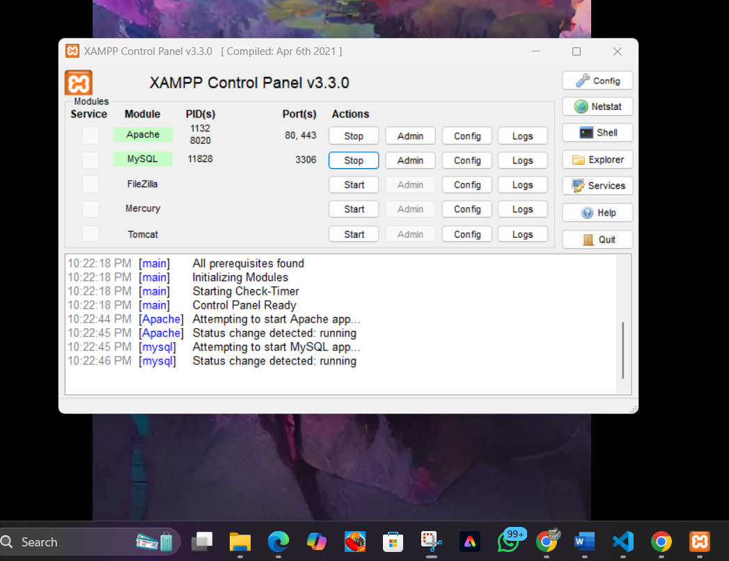

**CREATE DATABASE:**

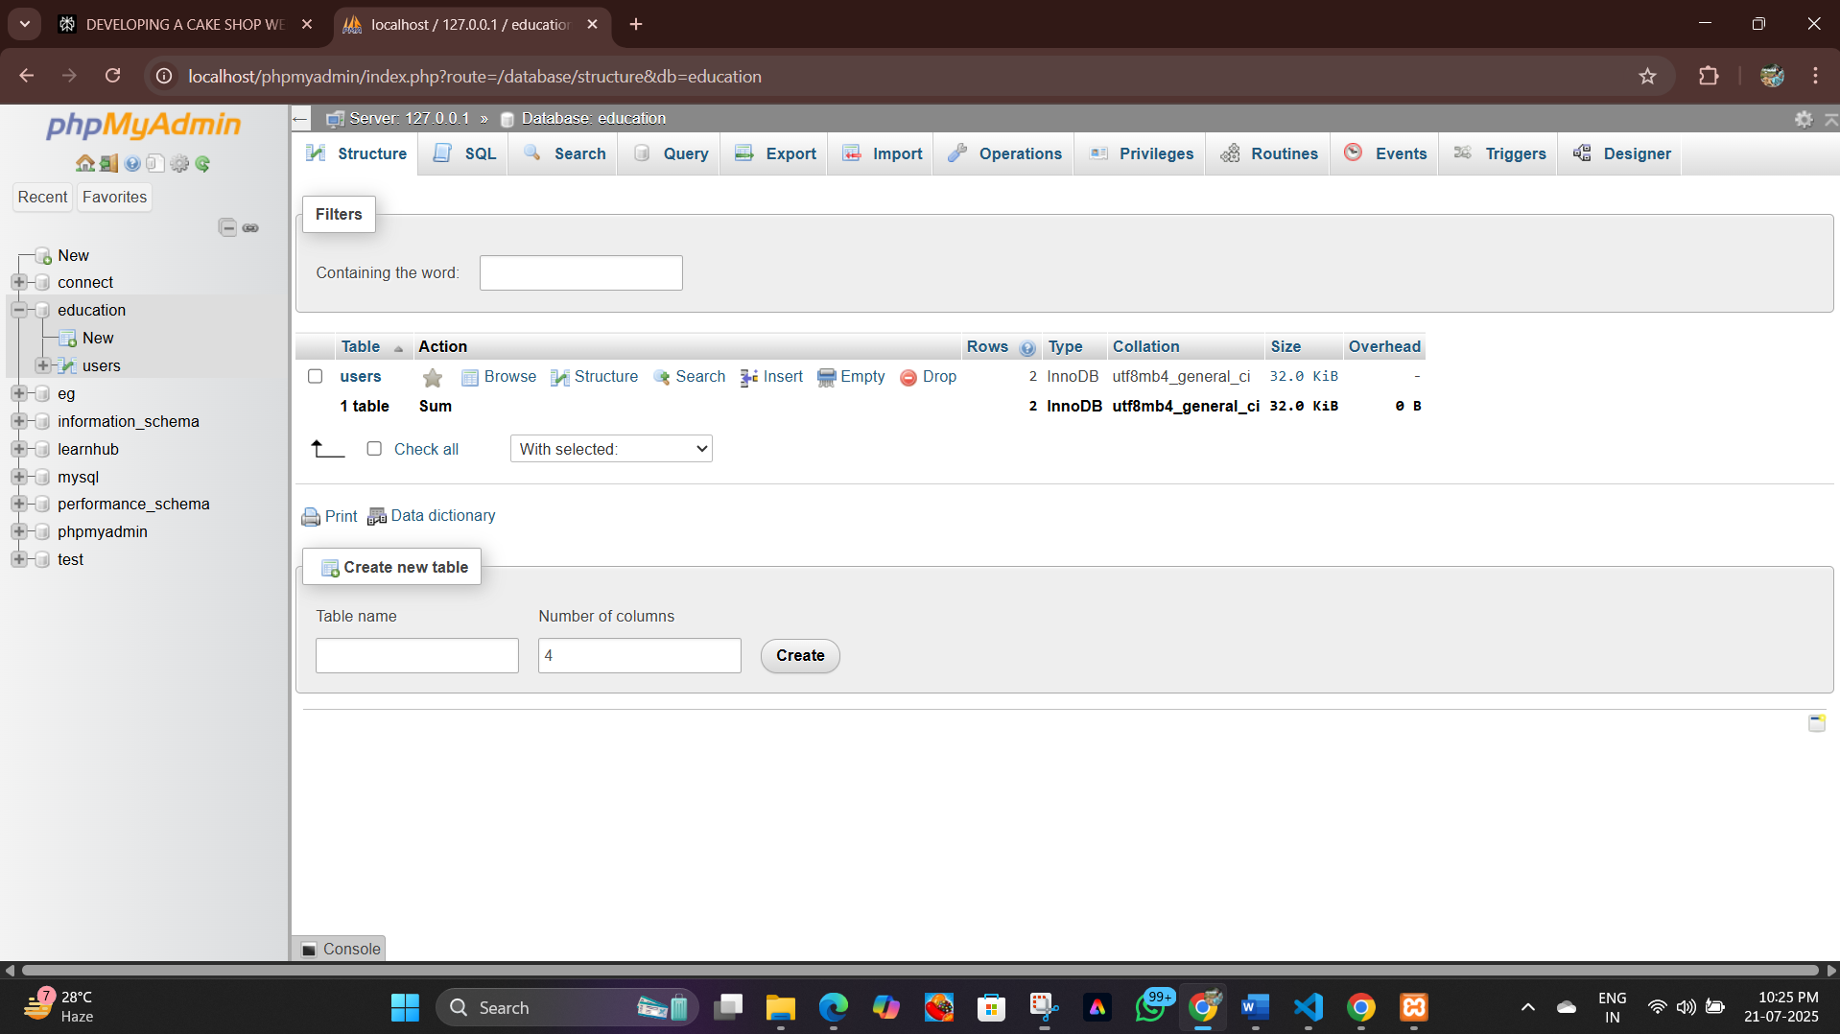

**RUN IN LOCAL HOST:**

[**http://localhost/project/login.html**](http://localhost/project/login.html)

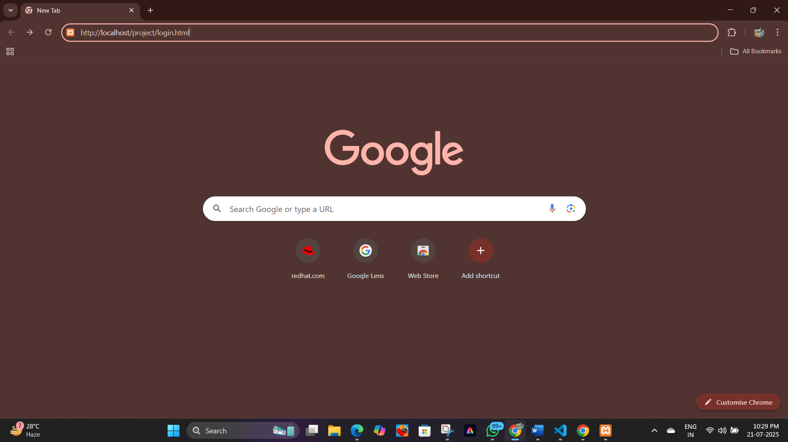

1. Registration/Login:
   * Users register with name, email, and password.
   * Passwords are securely hashed using PHP’s password_hash and verified with password_verify.
   * Post-login, sessions are managed to allow access to user-specific pages.

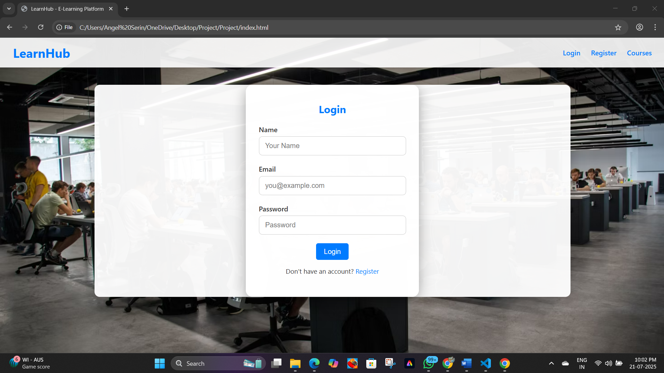

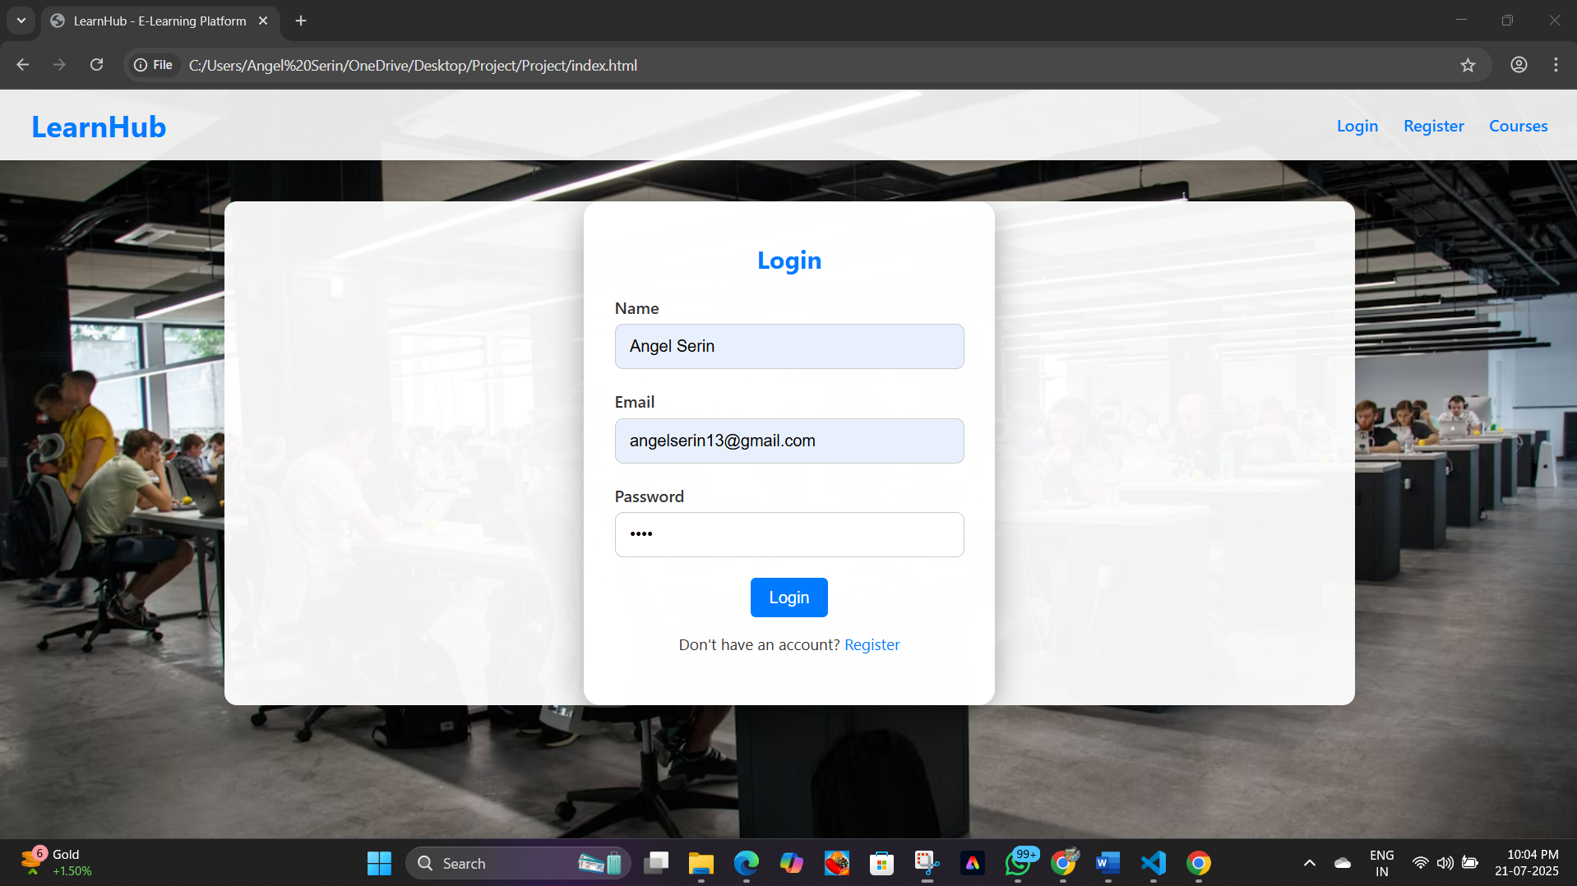

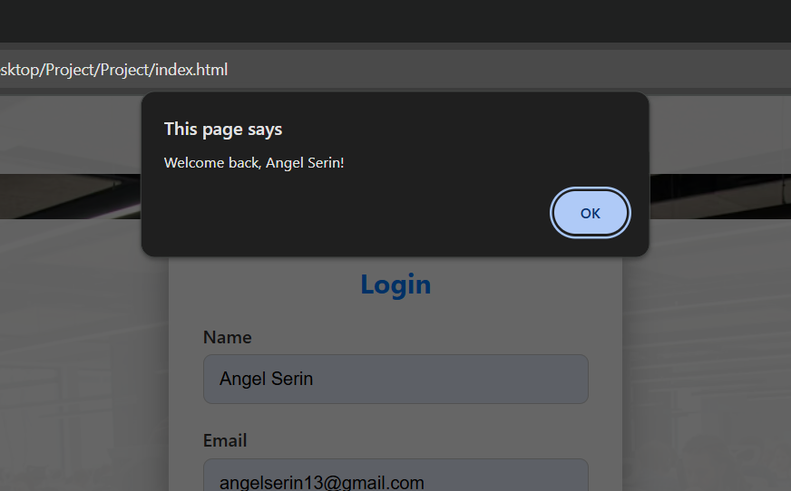

**2.Dashboard and Courses:**

* + Authenticated users are redirected to a personalized dashboard showing available courses in a modern grid layout, with course images and brief summaries.
  + Users can navigate to course details, where extended descriptions and downloadable notes are available.

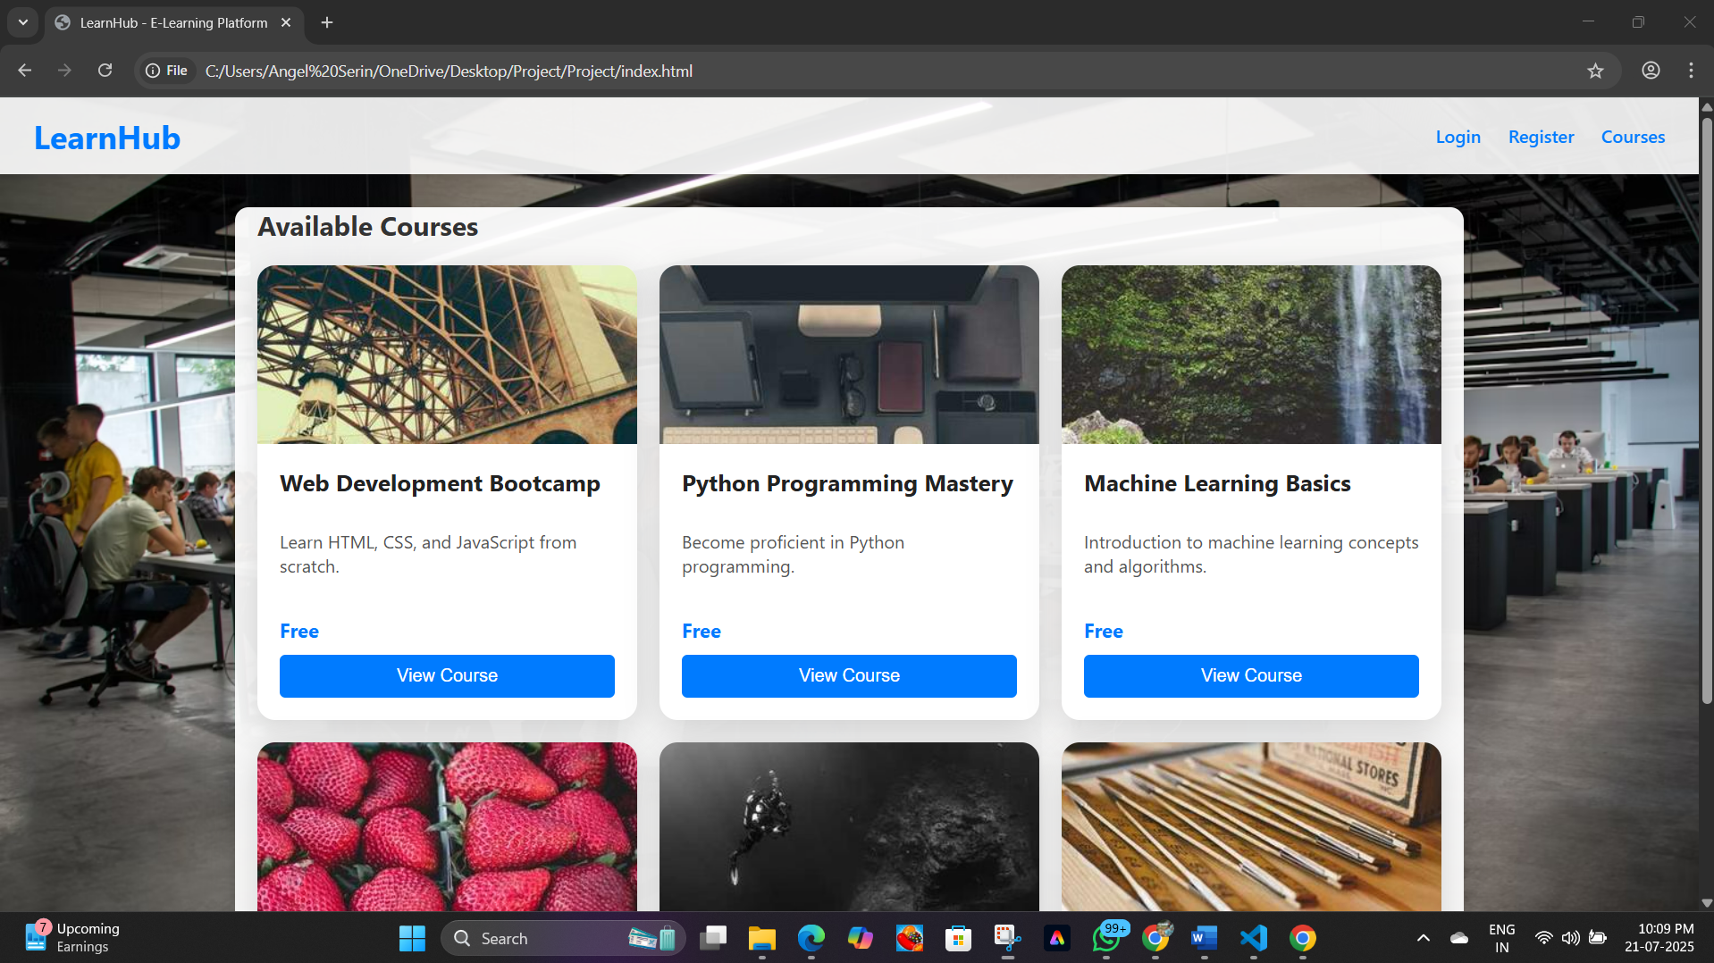

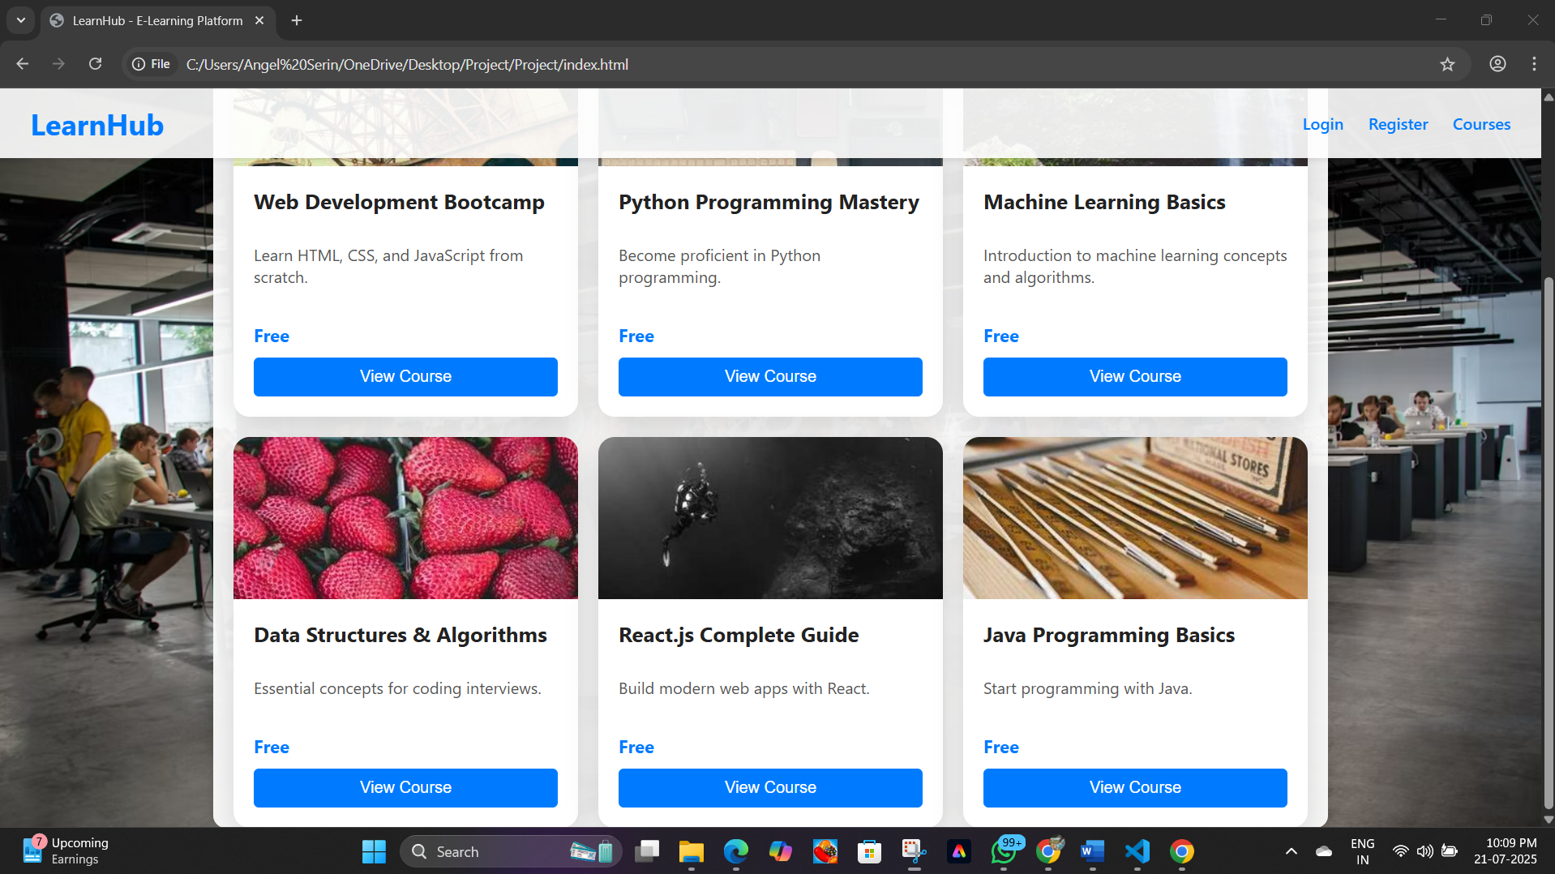

**3.Course Notes and Interactivity:**

* + Rich HTML notes are displayed and can be downloaded as PDF via jsPDF.
  + The system tracks whether notes have been downloaded before allowing users to take the course exam, encouraging thorough study.

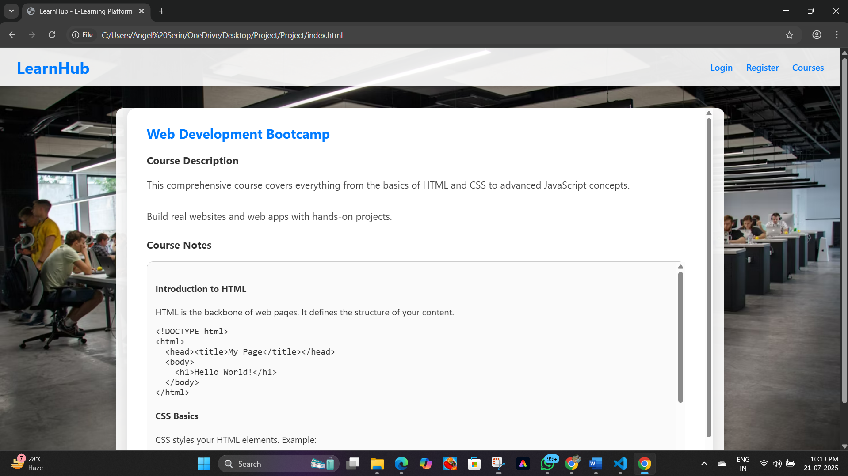

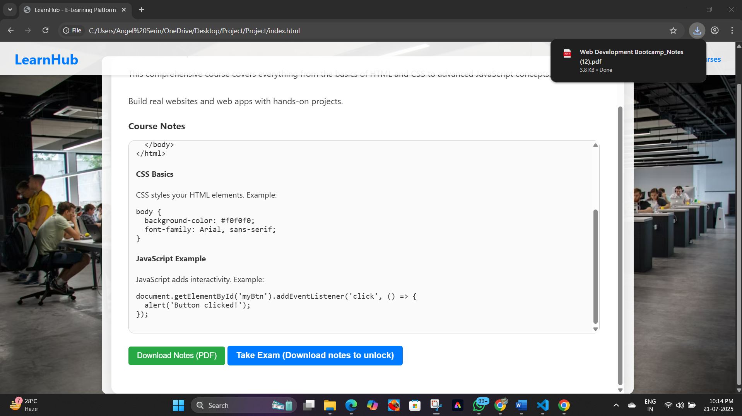

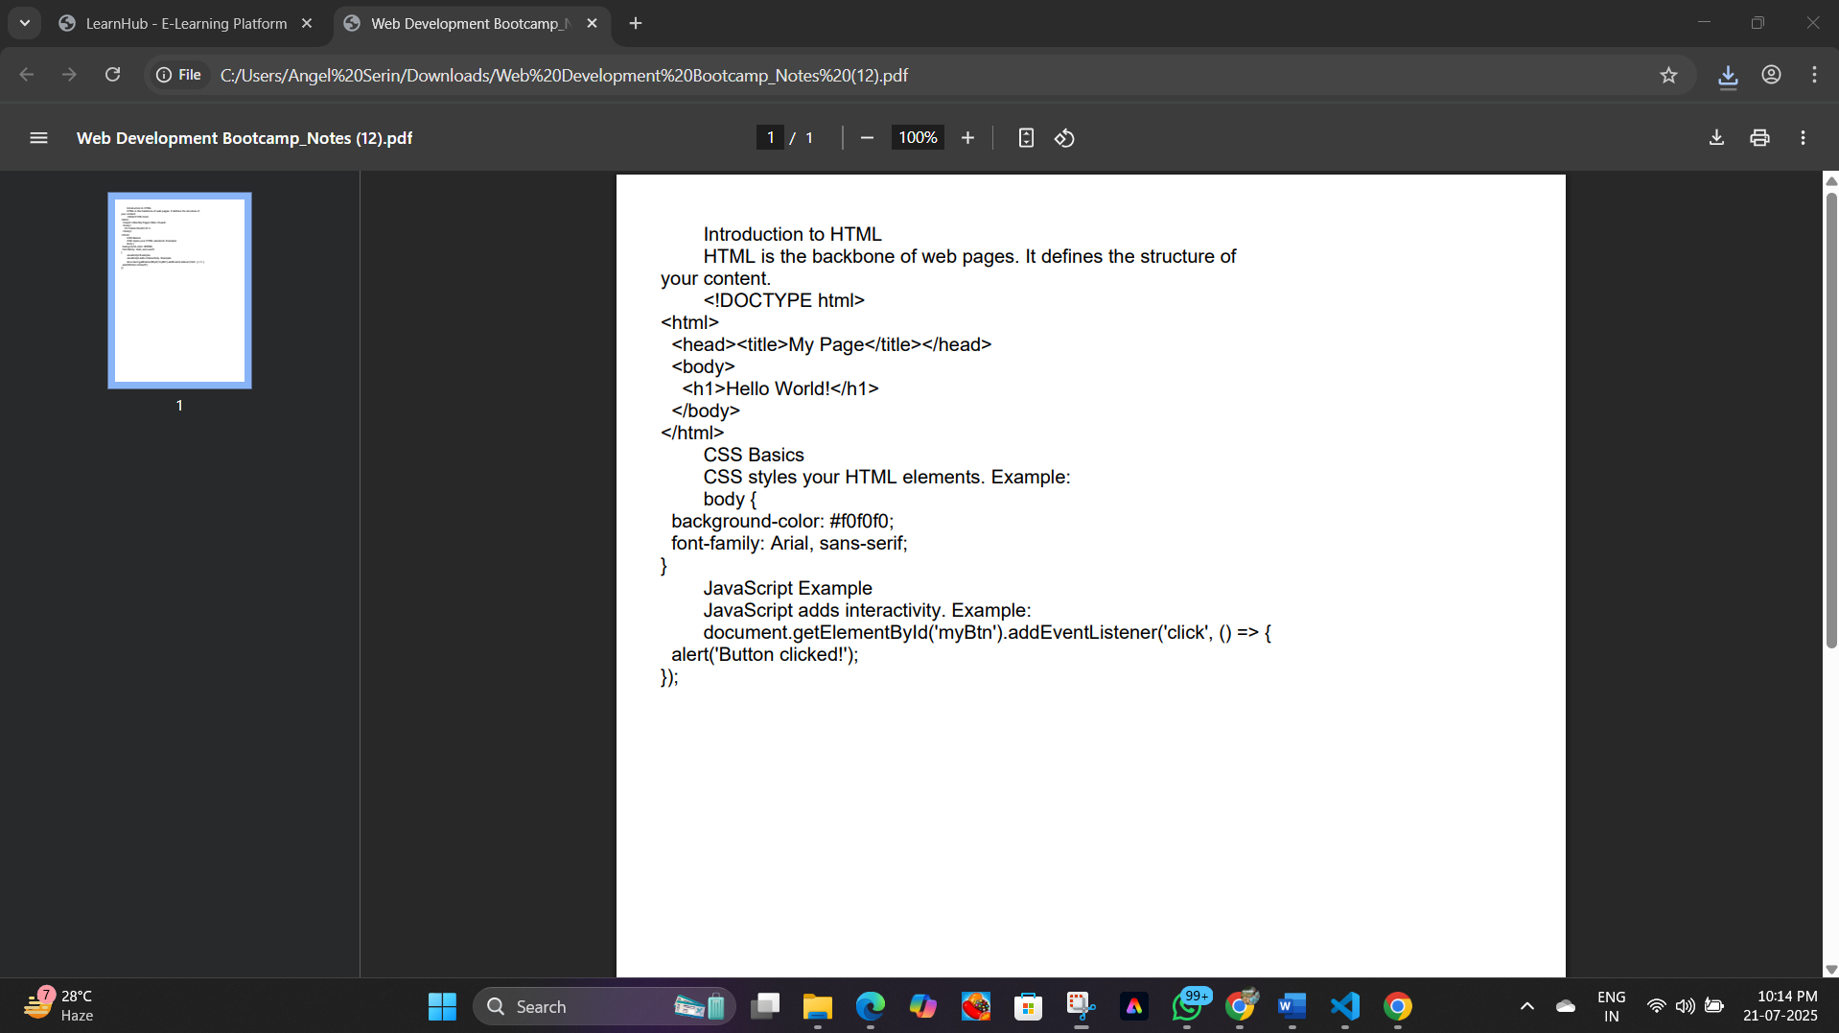

**4.Exam Module:**

* + Interactive MCQ exams with auto-evaluation.
  + Immediate feedback of score and pass/fail status.
  + Logic ensures all questions must be answered before submission.

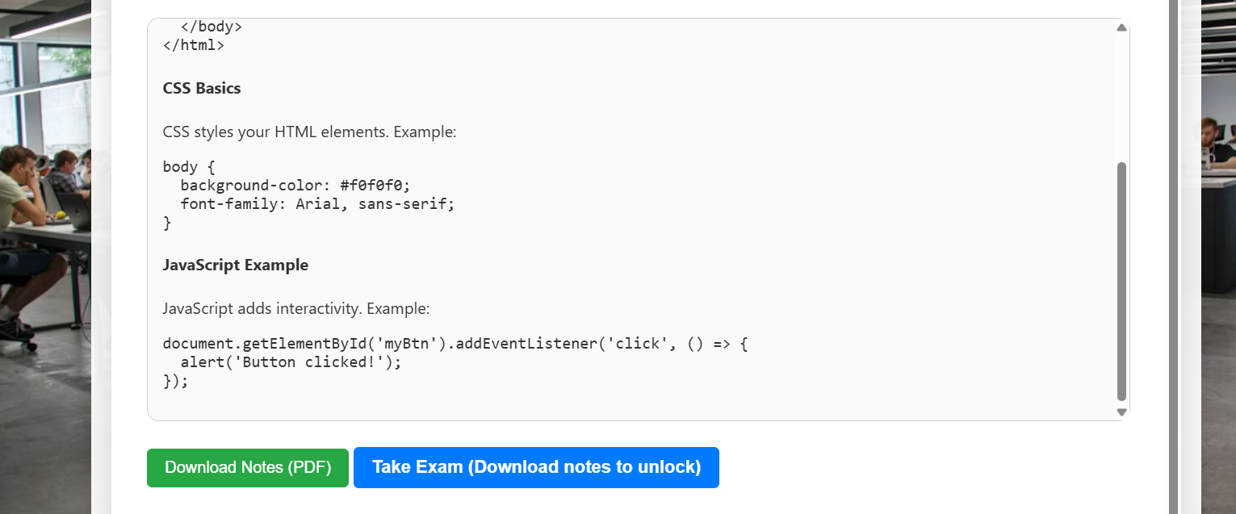

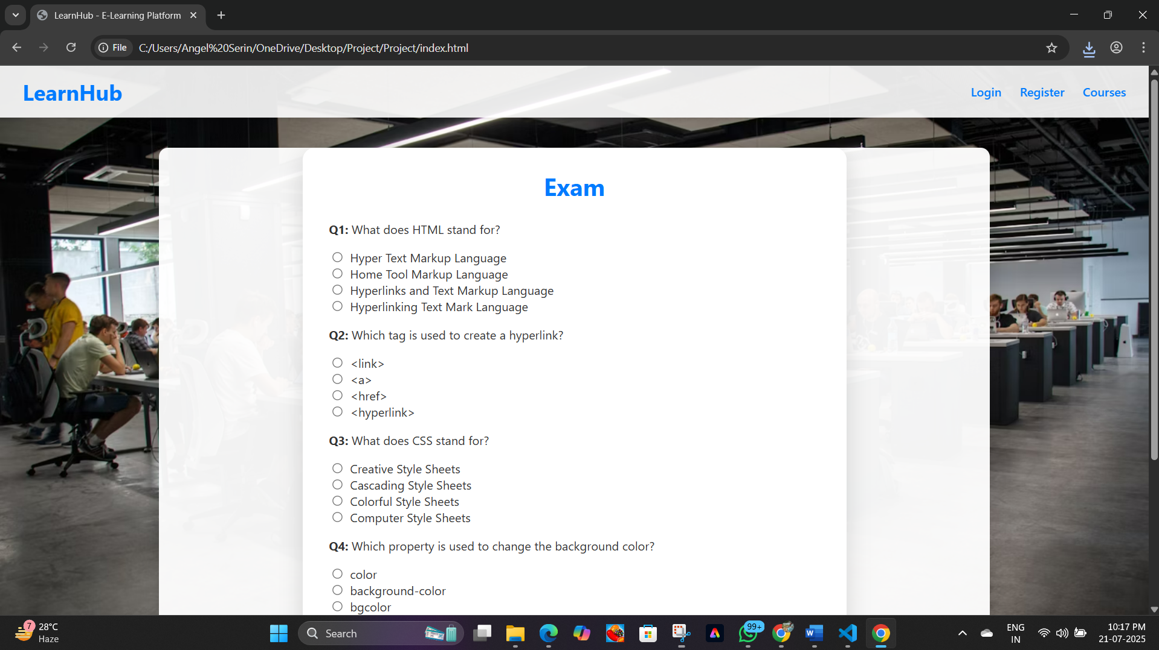

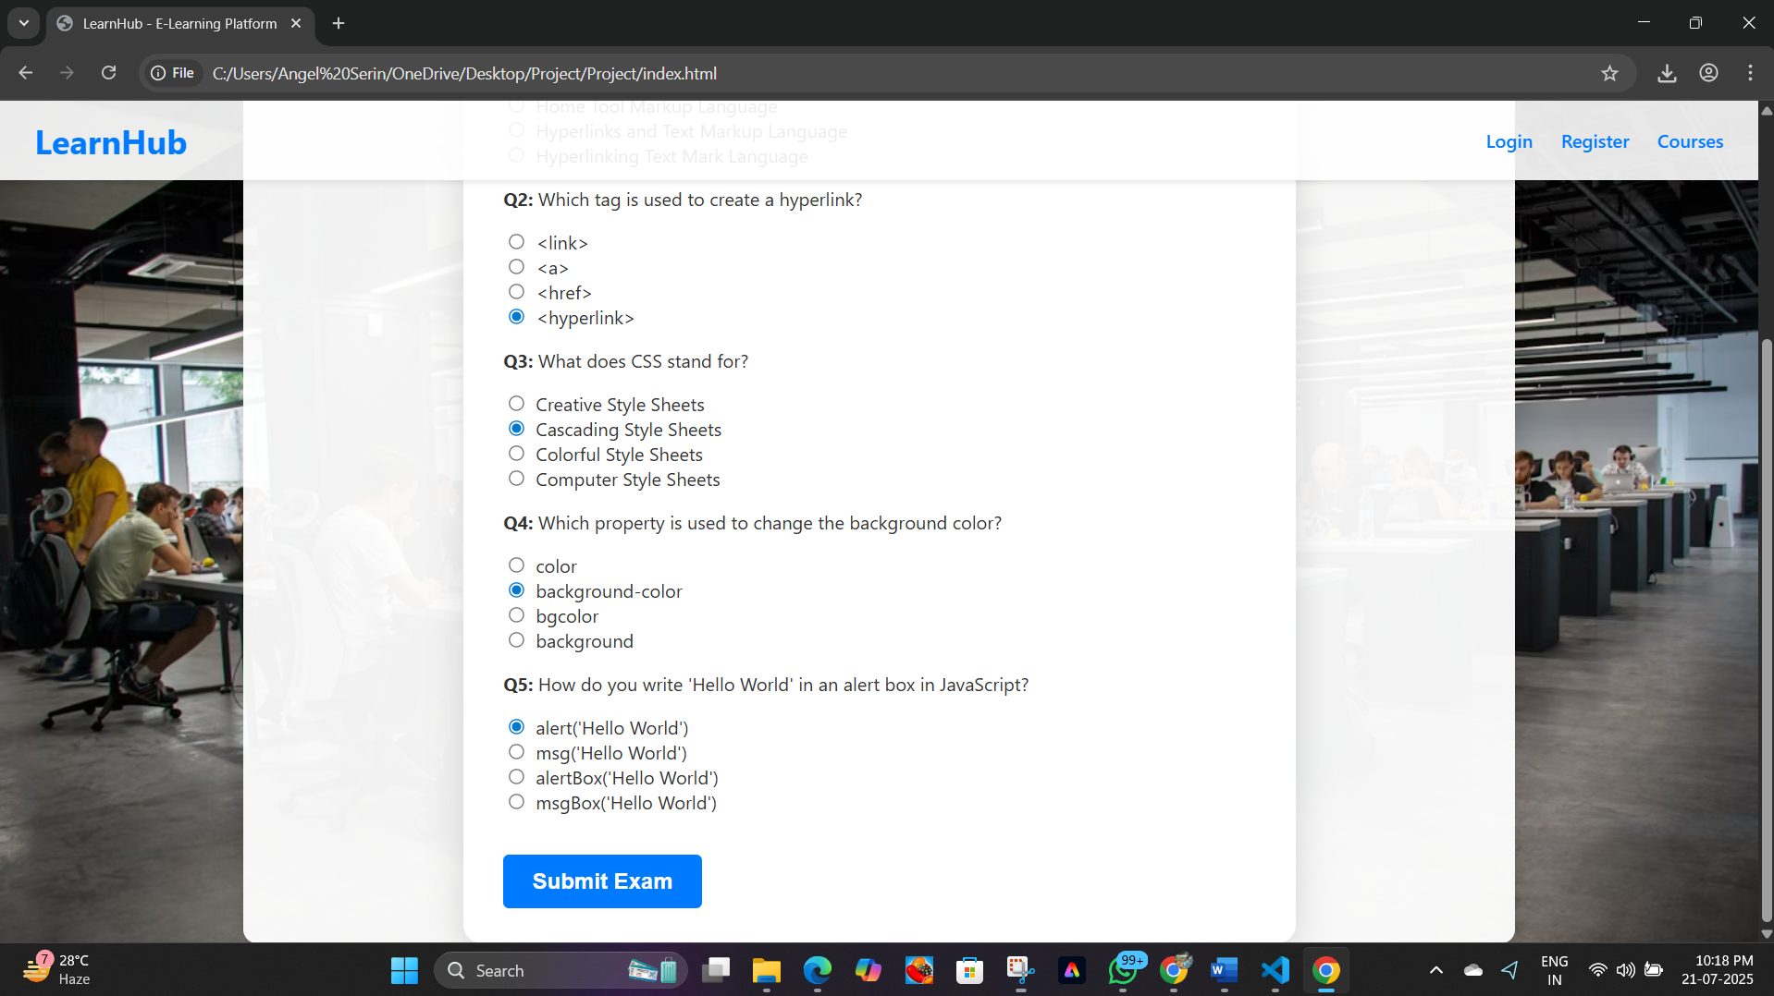

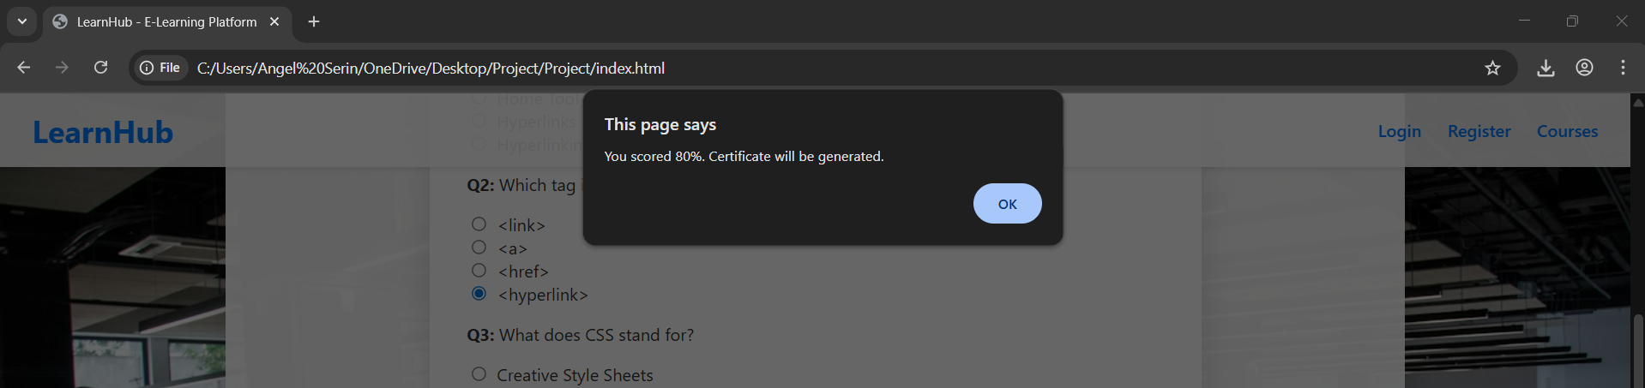

**5.Certification:**

* + On clearing the exam, an attractive certificate (styled with gradients and custom fonts) is generated instantly as a downloadable PDF.
  + Certificate includes user name, course name, and performance score.

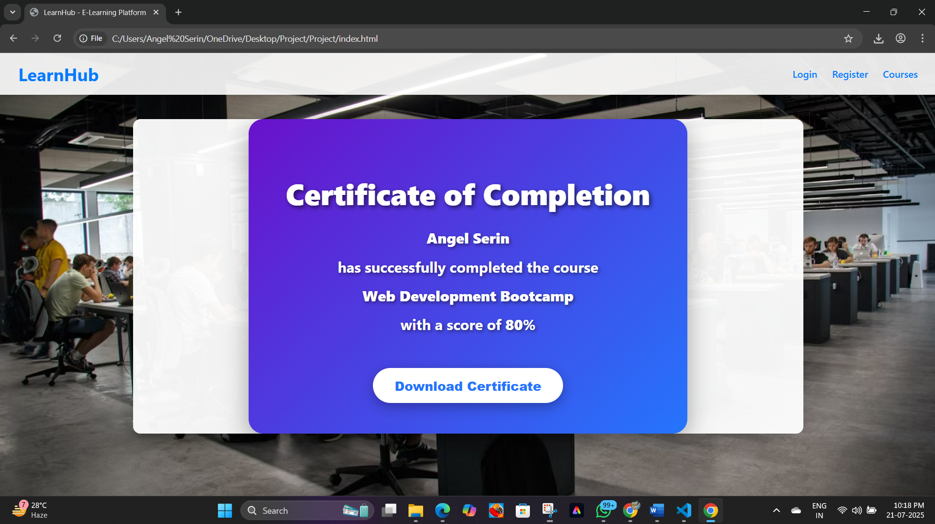

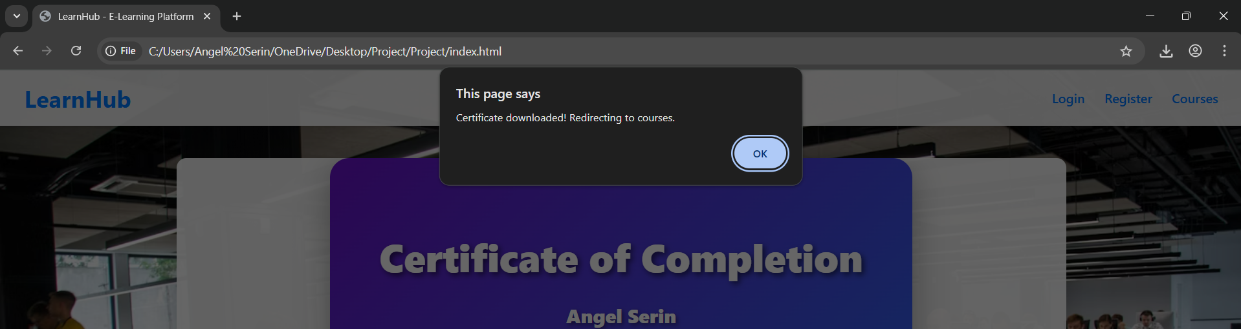

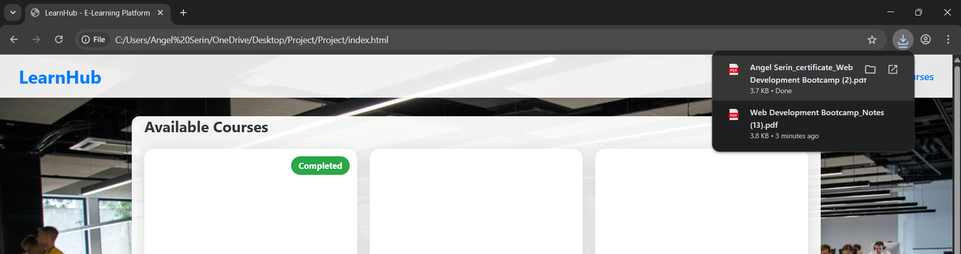

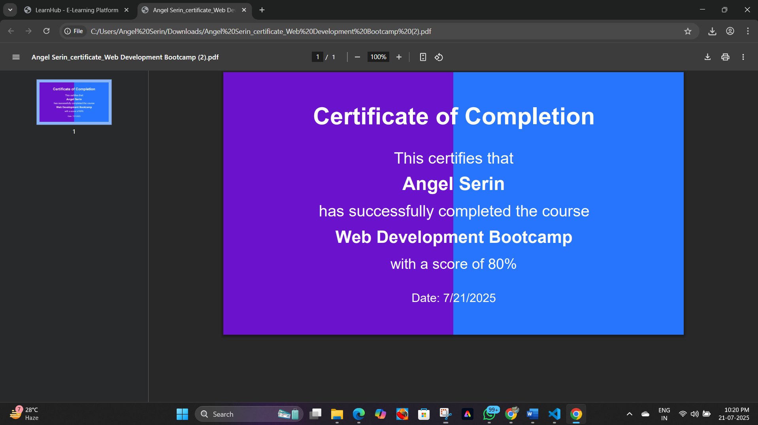

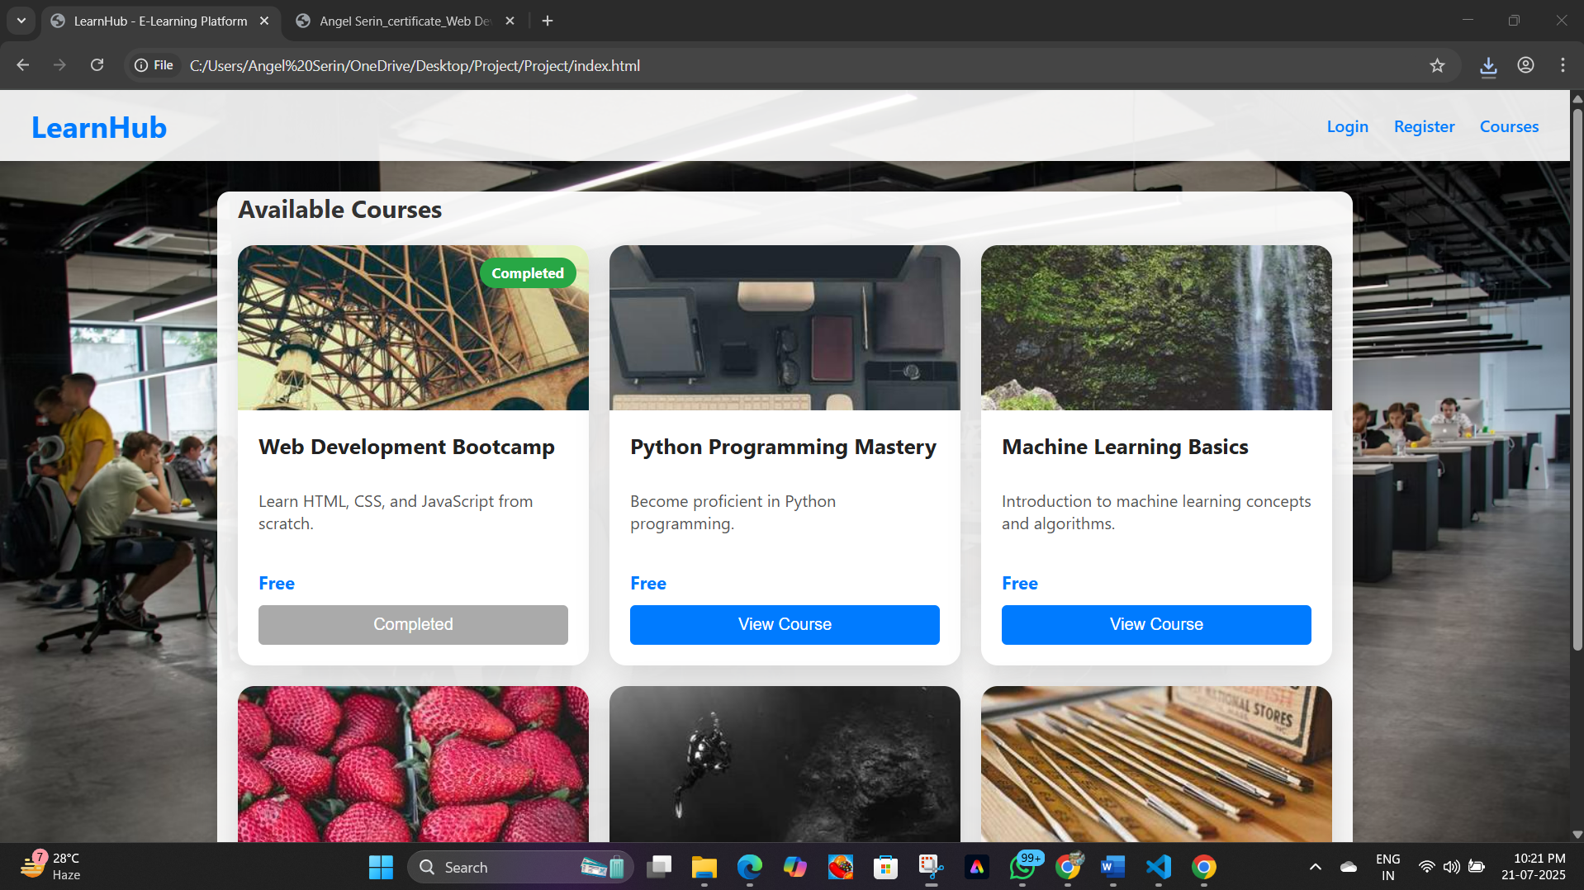

**RESULT**

The website successfully implements a sleek and user-friendly E-Learning platform, providing an interactive and visually appealing learning experience. Here are the key outcomes:

1. **Responsive Layout**
   * The platform adapts seamlessly across desktops, tablets, and smartphones. Modern CSS ensures a consistent, readable, and organized presentation for users on any device.
2. **Interactive Elements**
   * **Course Cards:** Courses are displayed as interactive cards in a responsive grid, allowing learners to easily browse offerings.
   * **Exams & Certificates:** Each course includes quizzes and on successful completion, students can instantly download a personalized PDF certificate.
   * **Notes Download:** Users can download course notes in PDF format for offline learning.
3. **User Engagement**
   * **Registration & Login:** Simple registration and login flows ensure users can securely access their courses.
   * **Progress Tracking:** After passing exams, courses are marked as "Completed", helping users track their progress.
4. **Visual Appeal**
   * The website uses an attractive background image and a modern, color-coordinated theme. Subtle box shadows, gradients, and rounded corners give the interface a polished, professional look.
5. **Accessibility & Ease of Use**
   * Clear navigation bar and labeled sections allow users to easily find courses, login/register, and download certificates.
   * Key actions (like exams and downloads) are accessible with obvious buttons and prompts.
6. **Technical Highlights**
   * **PDF Generation:** Certificates and notes are generated client-side using jsPDF, providing instant download without server delay.
   * **Dynamic Sections:** Only relevant page sections are displayed at a time, minimizing clutter and guiding the user journey step by step.

**CONCLUSION**

The result is a fully functional, responsive, and visually attractive e-learning platform that empowers users to browse, complete, and earn certificates for various online courses. All essential features—from user authentication, interactive content, to downloadable certificates—work smoothly across devices, ensuring a high-quality learning and engagement experience for all users.